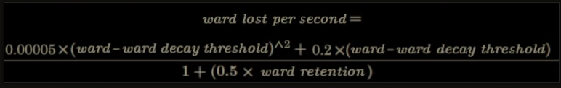
(0.00005 ward ^ 2 + 0.2 ward) / (1 + 0.5 retention) = ward per second
0.00005 ward ^ 2 + 0.2 ward = ward per second (1 + 0.5 retention)
0.00005 ward ^ 2 + 0.2 ward - ward per second (1 + 0.5 retention) = 0
a = 0.00005
b = 0.2
c = - ward per second (1 + 0.5 retention)
D = (b^2 – 4ac) = 0.2^2 - 4 * 0.00005 * c = 0.04 - 0.0002 * c
x1 =
(-b + sqrt(D)) / 2a =
(-0.2 - sqrt(c) / 0.0001 =
10000 * (-0.2 + sqrt(D)) =
10000 * (-0.2 + sqrt(0.04 - 0.0002 * c)) =
10000 * (-0.2 + sqrt(0.04 - 0.0002 * (- ward per second (1 + 0.5 retention)))) =
10000 * (-0.2 + sqrt(0.04 + 0.0002 * ward per second (1 + 0.5 retention))))

